05b. Member Tool
- Purpose
- Accessing a Member's Account
- Available Information and Functions

Purpose
Fraud Support agents are unlikely to use the Member Tool in their day-to-day work, but it can be helpful to our team in certain situations.

Accessing a Member's Account
You can bring up a member's account by entering their email address in the search box and selecting "email" from the drop-down menu.
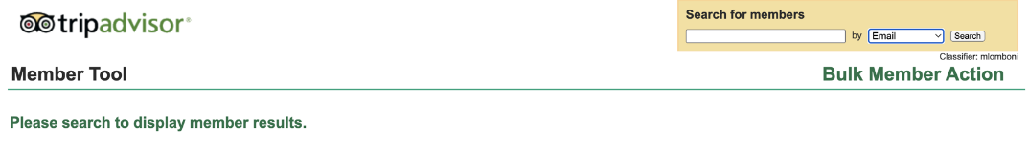

Available Information and Functions
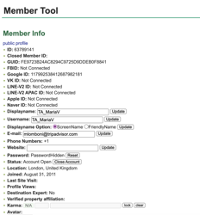
- View the user's name.
- Check if they are a Destination Expert and see their join date.
- Ban members from submitting reviews or forum posts, or ban their account altogether.
- Usage Constraint: T1 should only use the tool for information gathering and must not take actions directly. Follow established escalation paths for bans or removals.
- Reliability Warning: Do not use "Owners Info" for decisions on property affiliation as the logic is outdated.

